Morning Prayer

You may wish to light a candle and have some reflective music playing in the background.
The Lord is good, a strong refuge when trouble comes. God is close to those who trust in him.
Nahum 1.7

Opening Sentences
O Lord, open our lips and our mouth shall proclaim your praise.
The night has passed, and the day lies open before us; let us pray with one heart and mind.
Pause for reflection as you offer the day to God.
As we rejoice in the gift of this new day, so may the light of your presence, O God, set our hearts on fire with love for you; now and for ever. Amen.
Bible Reading
You may wish to say Psalm 23 or another psalm here, such as Psalm 16 or Psalm 139.
Psalm 23
1 The Lord is my shepherd; ♦︎
therefore can I lack nothing.
2 He makes me lie down in green pastures ♦︎
and leads me beside still waters.
3 He shall refresh my soul ♦︎
and guide me in the paths of righteousness for his name’s sake.
4 Though I walk through the valley of the shadow of death,
I will fear no evil; ♦︎
for you are with me;
your rod and your staff, they comfort me.
5 You spread a table before me
in the presence of those who trouble me; ♦︎
you have anointed my head with oil
and my cup shall be full.
6 Surely goodness and loving mercy shall follow me
all the days of my life, ♦︎
and I will dwell in the house of the Lord for ever.
Glory to the Father and to the Son
and to the Holy Spirit;
as it was in the beginning is now
and shall be for ever. Amen

You may wish to use the weekly pattern of short readings given below, or choose a passage of your own.
Sunday Morning
But now thus says the Lord, he who created you, O Jacob, he who formed you, O Israel:
Do not fear, for I have redeemed you; I have called you by name, you are mine.
When you pass through the waters, I will be with you; and through the rivers, they shall not overwhelm you; when you walk through fire you shall not be burned, and the flame shall not consume you. For I am the Lord your God, the Holy One of Israel, your Saviour.
Isaiah 43.1-3a
Monday Morning
‘Do not let your hearts be troubled. Believe in God, believe also in me. In my Father’s house there are many dwelling-places. If it were not so, would I have told you that I go to prepare a place for you? And if I go and prepare a place for you, I will come again and will take you to myself, so that where I am, there you may be also. And you know the way to the place where I am going.’ Thomas said to him, ‘Lord, we do not know where you are going. How can we know the way?’ Jesus said to him, ‘I am the way, and the truth, and the life. No one comes to the Father except through me.
John 14.1-6
Tuesday Morning
Finally, beloved, whatever is true, whatever is honourable, whatever is just, whatever is pure, whatever is pleasing, whatever is commendable, if there is any excellence and if there is anything worthy of praise, think about these things. Keep on doing the things that you have learned and received and heard and seen in me, and the God of peace will be with you.
Philippians 4.8-9
Wednesday Morning
Let the word of Christ dwell in you richly; teach and admonish one another in all wisdom; and with gratitude in your hearts sing psalms, hymns, and spiritual songs to God. And whatever you do, in word or deed, do everything in the name of the Lord Jesus, giving thanks to God the Father through him.
Colossians 3.16,17
Thursday Morning
You are no longer strangers and aliens, but you are citizens with the saints and also members of the household of God, built upon the foundation of the apostles and prophets, with Christ Jesus himself as the cornerstone. In him the whole structure is joined together and grows into a holy temple in the Lord; in whom you also are built together spiritually into a dwelling-place for God.
Ephesians 2.19-22
Friday Morning
Let love be genuine; hate what is evil, hold fast to what is good; love one another with mutual affection; outdo one another in showing honour. Do not lag in zeal, be ardent in spirit, serve the Lord. Rejoice in hope, be patient in suffering, persevere in prayer.
Romans 19.9-12
Saturday Morning
He said to his disciples, ‘Therefore I tell you, do not worry about your life, what you will eat, or about your body, what you will wear. For life is more than food, and the body more than clothing. Consider the ravens: they neither sow nor reap, they have neither storehouse nor barn, and yet God feeds them. Of how much more value are you than the birds! And can any of you by worrying add a single hour to your span of life? If then you are not able to do so small a thing as that, why do you worry about the rest? Consider the lilies, how they grow: they neither toil nor spin; yet I tell you, even Solomon in all his glory was not clothed like one of these. But if God so clothes the grass of the field, which is alive today and tomorrow is thrown into the oven, how much more will he clothe you—you of little faith! And do not keep striving for what you are to eat and what you are to drink, and do not keep worrying. For it is the nations of the world that strive after all these things, and your Father knows that you need them. Instead, strive for his kingdom, and these things will be given to you as well.
Luke 12.22-31

Prayers
Almighty and everlasting God, we thank you that you have brought us safely to the beginning of this day. Keep us from falling into sin or running into danger; order us in all our doings and guide us to do always what is righteous in your sight; through Jesus Christ our Lord. Amen.
Keep us, good Lord, under the shadow of your mercy in this time of uncertainty and distress. Sustain and support the anxious and fearful, and lift up all who are brought low; that we may rejoice in your comfort knowing that nothing can separate us from your love in Christ Jesus our Lord. Amen.

The Lord’s Prayer
Our Father in heaven, hallowed be your name, your kingdom come, your will be done, on earth as in heaven. Give us today our daily bread. Forgive us our sins as we forgive those who sin against us. Lead us not into temptation but deliver us from evil. For the kingdom, the power, and the glory are yours, now and for ever. Amen.
(or)
Our Father, who art in heaven, hallowed be thy name; thy kingdom come; thy will be done; on earth as it is in heaven. Give us this day our daily bread. And forgive us our trespasses, as we forgive those who trespass against us. And lead us not into temptation; but deliver us from evil. For thine is the kingdom, the power and the glory, for ever and ever. Amen.

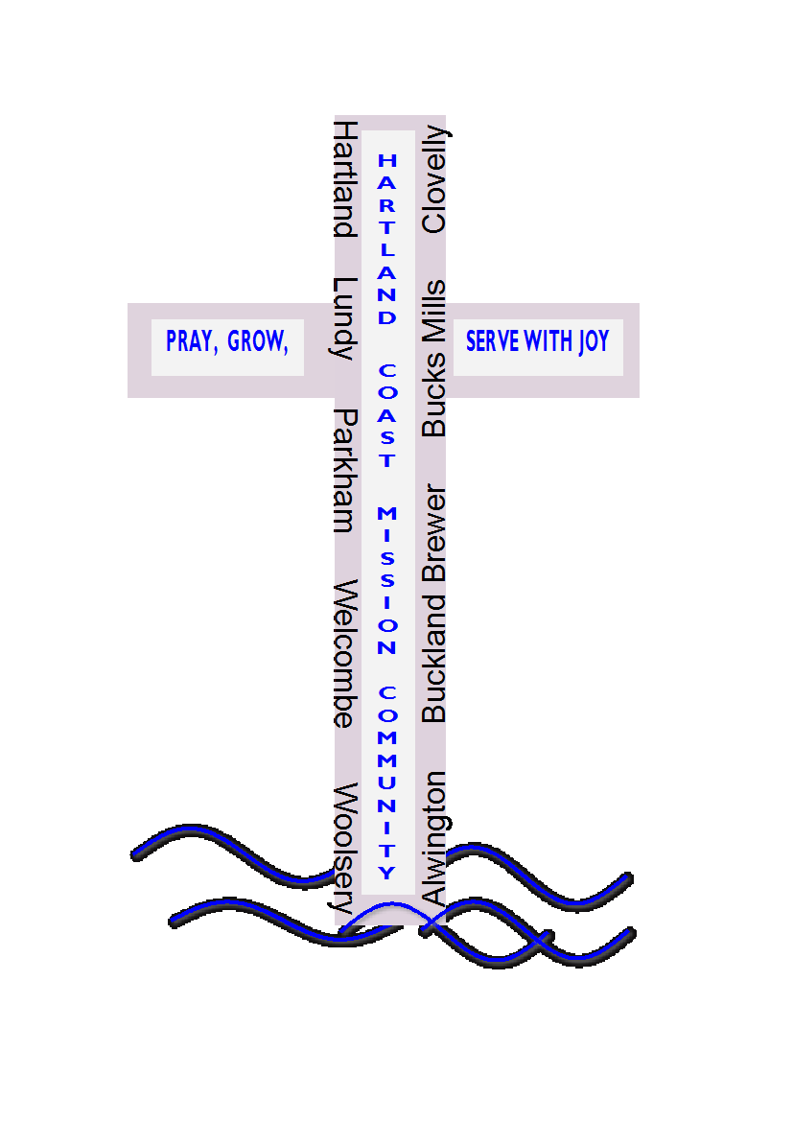
The Conclusion
The Lord bless us, and preserve us from all evil, and keep us in eternal life.
Amen.

Let us bless the Lord.
Thanks be to God.

Materials in this booklet are drawn from Common Worship: Services and Prayers for the Church of England, Common Worship: Pastoral Services, and Common Worship: Daily Prayer, all of which are copyright © The Archbishops' Council of the Church of England

