Night Prayer

You may wish to light a candle and have some reflective music playing in the background.
The eternal God is your refuge, and underneath are the everlasting arms.
Deuteronomy 33.27
Opening Sentences
The Lord almighty grant us a quiet night and a perfect end. Amen.
Our help is in the name of the Lord
who made heaven and earth.

Pause and reflect on the day that is past.

Save us, O Lord, while waking, and guard us while sleeping, that awake we may watch with Christ and asleep may rest in peace.

Bible Reading

You may wish to say here Psalm 91 or Psalm 27, or another chosen psalm.

Psalm 91
1 Whoever dwells in the shelter of the Most High ♦︎
and abides under the shadow of the Almighty,
2 Shall say to the Lord, ‘My refuge and my stronghold, ♦︎
my God, in whom I put my trust.’
3 For he shall deliver you from the snare of the fowler ♦︎
and from the deadly pestilence.
4 He shall cover you with his wings
and you shall be safe under his feathers; ♦︎
his faithfulness shall be your shield and buckler.
5 You shall not be afraid of any terror by night, ♦︎
nor of the arrow that flies by day;
6 Of the pestilence that stalks in darkness, ♦︎
nor of the sickness that destroys at noonday.
7 Though a thousand fall at your side
and ten thousand at your right hand, ♦︎
yet it shall not come near you.
8 Your eyes have only to behold ♦︎
to see the reward of the wicked.
9 Because you have made the Lord your refuge ♦︎
and the Most High your stronghold,
10 There shall no evil happen to you, ♦︎
neither shall any plague come near your tent.
11 For he shall give his angels charge over you, ♦︎
to keep you in all your ways.
12 They shall bear you in their hands, ♦︎
lest you dash your foot against a stone.
13 You shall tread upon the lion and adder; ♦︎
the young lion and the serpent you shall trample underfoot.
14 Because they have set their love upon me,
therefore will I deliver them; ♦︎
I will lift them up, because they know my name.
15 They will call upon me and I will answer them; ♦︎
I am with them in trouble,
I will deliver them and bring them to honour.
16 With long life will I satisfy them ♦︎
and show them my salvation.

Glory to the Father and to the Son
and to the Holy Spirit;
as it was in the beginning is now
and shall be for ever. Amen.

You may wish to use one of the following short readings or choose a passage of your own.
Sunday Evening
You, O Lord, are in the midst of us, and we are called by your name; leave us not, O Lord our God.
Jeremiah 14.9
Monday Evening
Thus said the Lord God, the Holy One of Israel: In returning and rest you shall be saved; in quietness and in trust shall be your strength.
Isaiah 30.15

Tuesday Evening
Jesus said, ‘Come to me, all you that are weary and are carrying heavy burdens, and I will give you rest. Take my yoke upon you, and learn from me; for I am gentle and humble in heart, and you will find rest for your souls. For my yoke is easy, and my burden is light.
Matthew 11.28-end
Wednesday Evening
Humble yourselves under the mighty hand of God, so that he may exalt you in due time. Cast all your anxiety on him, because he cares for you.
1 Peter 5.6,7
Thursday Evening
Jesus said, ‘I have said this to you, so that in me you may have peace. In the world you face persecution. But take courage; I have conquered the world!’
John 16.33
Friday Evening
God has destined us not for wrath but for obtaining salvation through our Lord Jesus Christ, who died for us, so that whether we are awake or asleep we may live with him.
1 Thessalonians 5.9,10
Saturday Evening
Jesus said, ‘I am the light of the world. Whoever follows me will never walk in darkness but will have the light of life.’
John 8.12
Prayers
Merciful God, we entrust to your unfailing and tender care this night those who are ill or in pain, knowing that whenever danger threatens your everlasting arms are there to hold us safe. Comfort and heal them, and restore them to health and strength; through Jesus Christ our Lord. Amen.
Be present, O merciful God, and protect us through the silent hours of this night, so that we who are wearied by the changes and chances of this fleeting world, may rest upon your eternal changelessness; through Jesus Christ our Lord. Amen.

Visit this place, O Lord, we pray, and drive far from it the snares of the enemy; may your holy angels dwell with us in peace, and may your blessing be always upon us; through Jesus Christ our Lord. Amen.

The Lord’s Prayer
Our Father in heaven, hallowed be your name, your kingdom come, your will be done, on earth as in heaven. Give us today our daily bread. Forgive us our sins as we forgive those who sin against us. Lead us not into temptation but deliver us from evil. For the kingdom, the power, and the glory are yours, now and for ever. Amen.
(or)
Our Father, who art in heaven, hallowed be thy name; thy kingdom come; thy will be done; on earth as it is in heaven. Give us this day our daily bread. And forgive us our trespasses, as we forgive those who trespass against us. And lead us not into temptation; but deliver us from evil. For thine is the kingdom, the power and the glory, for ever and ever. Amen.

The Conclusion
In peace we will lie down and sleep;
for you alone, Lord, make us dwell in safety.
The Lord bless us and watch over us;
The Lord make his face to shine upon us and be gracious to us;
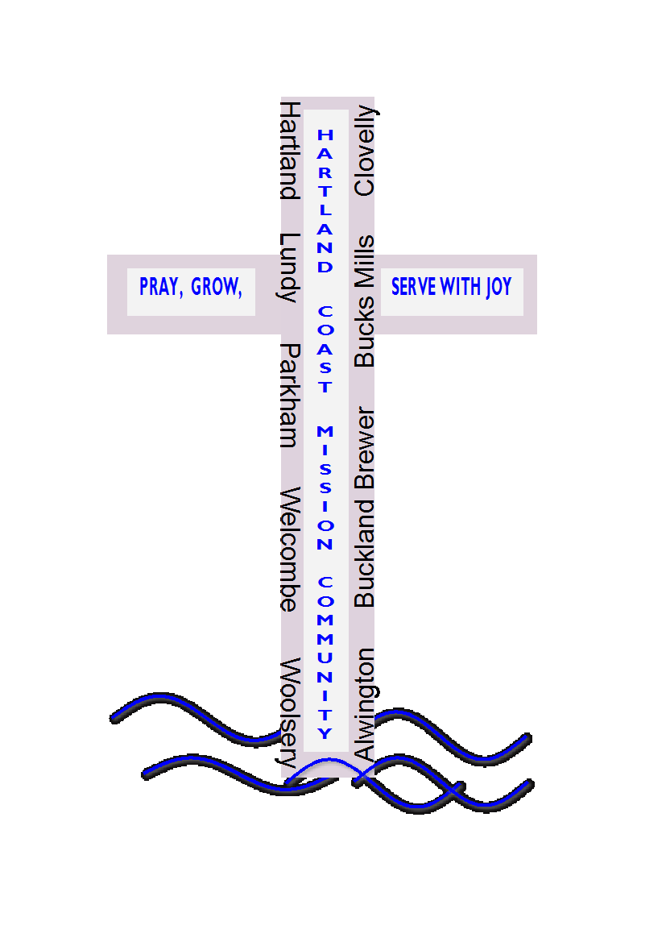
The Lord look kindly upon us and give us peace. Amen.

Materials in this booklet are drawn from Common Worship: Services and Prayers for the Church of England, Common Worship: Pastoral Services, and Common Worship: Daily Prayer, all of which are copyright © The Archbishops' Council of the Church of England

